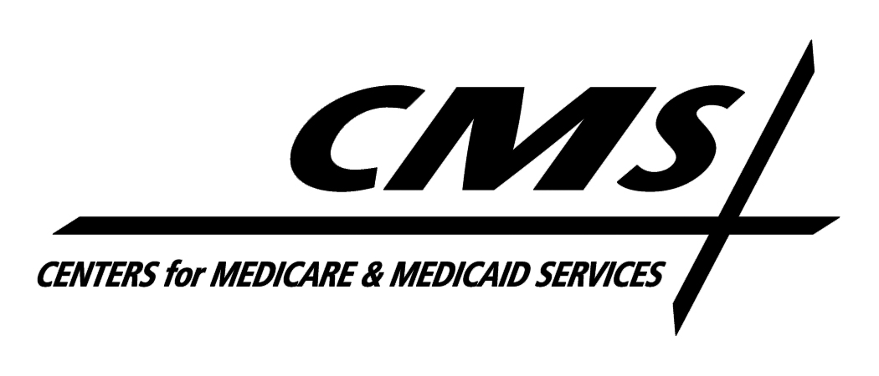Department of Health & Human Services
Centers for Medicare & Medicaid Services
7500 Security Boulevard, Mail Stop S3-13-15
Baltimore, Maryland 21244-1850

Center for Medicaid , CHIP, and Survey & Certification

October 21, 2010

TO: Drug Rebate Technical Contacts

FROM: Medicaid Drug Rebate Program

SUBJECT: Deleted Products--Immediate Action Required

The FDA has determined that the following active single-ingredient oral colchicine NDCs are unapproved new drugs within the meaning of section 201(p) of the Federal Food, Drug, and Cosmetic Act, subject to enforcement action, and cannot be marketed without appropriate FDA approval. 75 Fed. Reg. 60768 (October 1, 2010). According to the FDA, these products do not have approved New Drug Applications; therefore, the NDCs do not meet the definition of a covered outpatient drug as defined in Section 1927(k) of the Social Security Act and are subsequently no longer eligible for inclusion in the rebate program. Consequently, these NDCs should be deleted from your state Medicaid Drug Rebate system as of the date of this notice. You may notice several other single-ingredient oral colchicine NDCs in your systems that are not included in the list below. It is our understanding that the FDA is allowing certain unapproved single-ingredient oral colchicine NDCs to be manufactured until November 15, 2010; therefore, we may take similar action on other colchicine NDCs at a later date.

The labelers of the single-ingredient oral colchicine products listed below are responsible for paying rebates on these NDCs if they were dispensed prior to the date of this notice. In addition, states should be aware that the fourth quarter 2010 tape to states will be the last quarterly tape that will include these NDCs in order to facilitate rebate billing for any utilization that occurred in good faith prior to the date of this notice. As a reminder, while these products are not eligible for Medicaid coverage under the Medicaid Drug Rebate Program, they might be eligible for coverage under other Medicaid benefit categories such as home health services or EPSDT services, depending on whether such coverage is consistent with the State plan.

NDC Product Name

00591-0944 COLCHICINE 0.6MG
00603-3052 COLCHICINE 0.6 MG TAB
51552-0991 COLCHICINE USP

